**1: Using Filters to Remove Attributes**

in this we remove columns, in this way we decrease the attributes that are not used for out processing, we decrease the preprocessing for faster results and much more

-Feature Selection

-Faster results

-demonically reduction

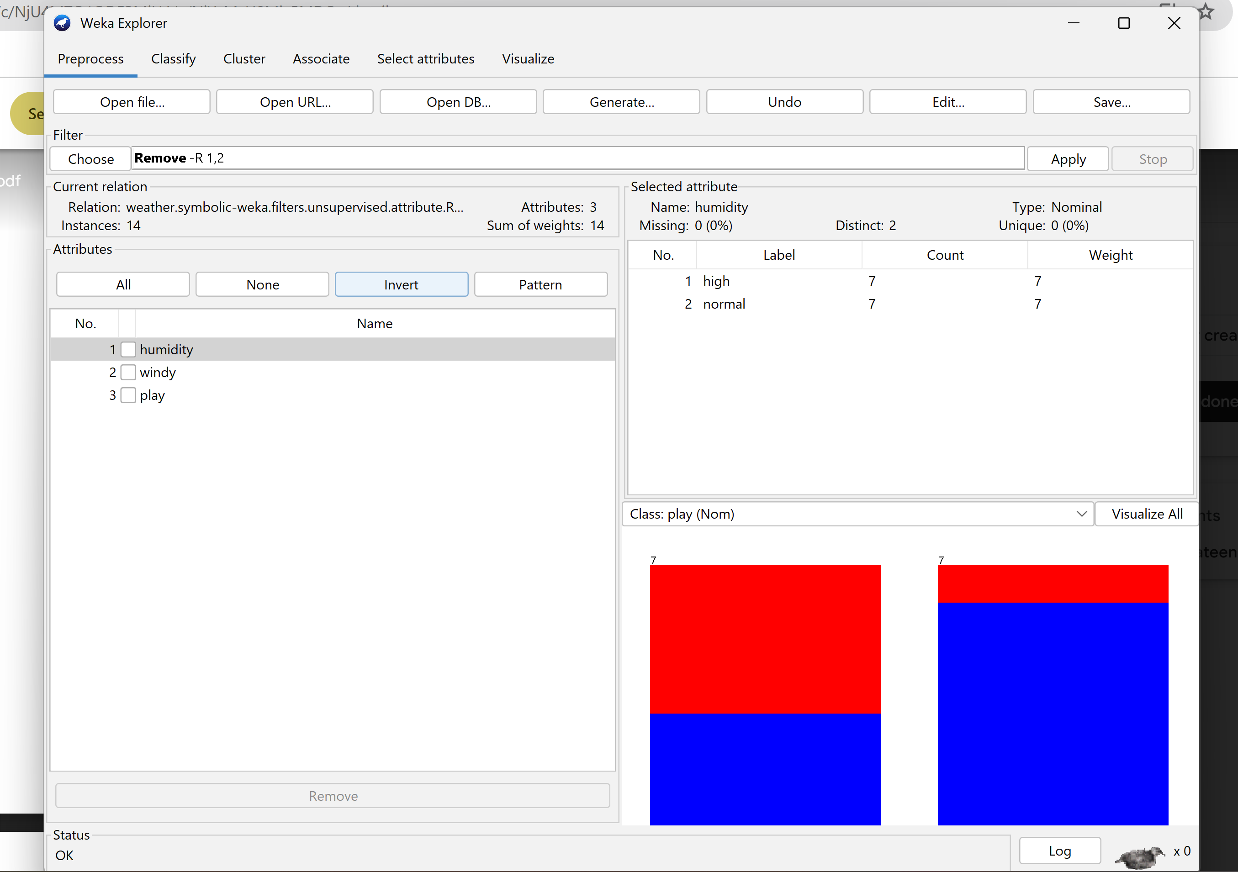

**2: Handling missing data**

it is important in a way that if we don’t remove these then it miss lead to faulty results like we miss to predict the exact data. This software works on algorithm that if we have numeric data then it by default select mean and if we have ordinal data then it select mode

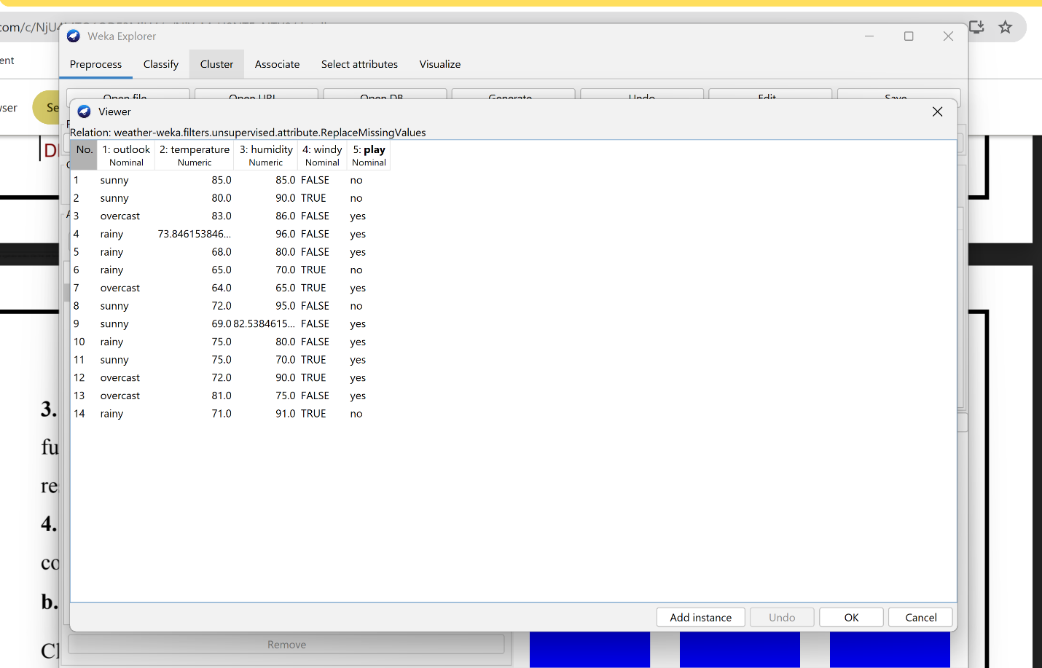

**3: Using Filters to handle outliers and extreme values**

If we have to see outliers of every attribute we chose True in Inter cortile attribute then simply we count on selecting columns from filter screen

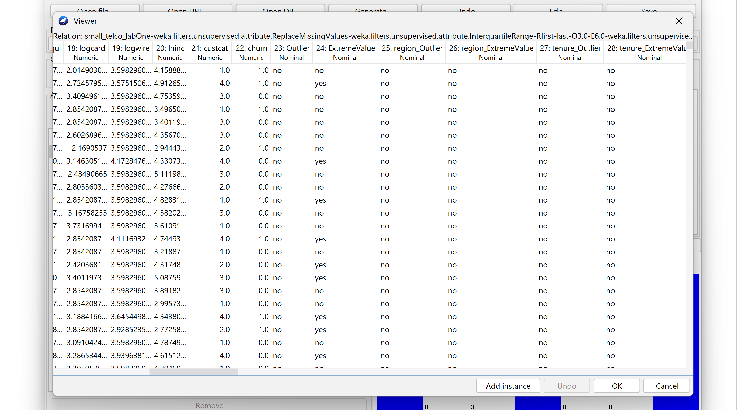

Remove these attributes as these only contain only yes hence these do not affect the label/output

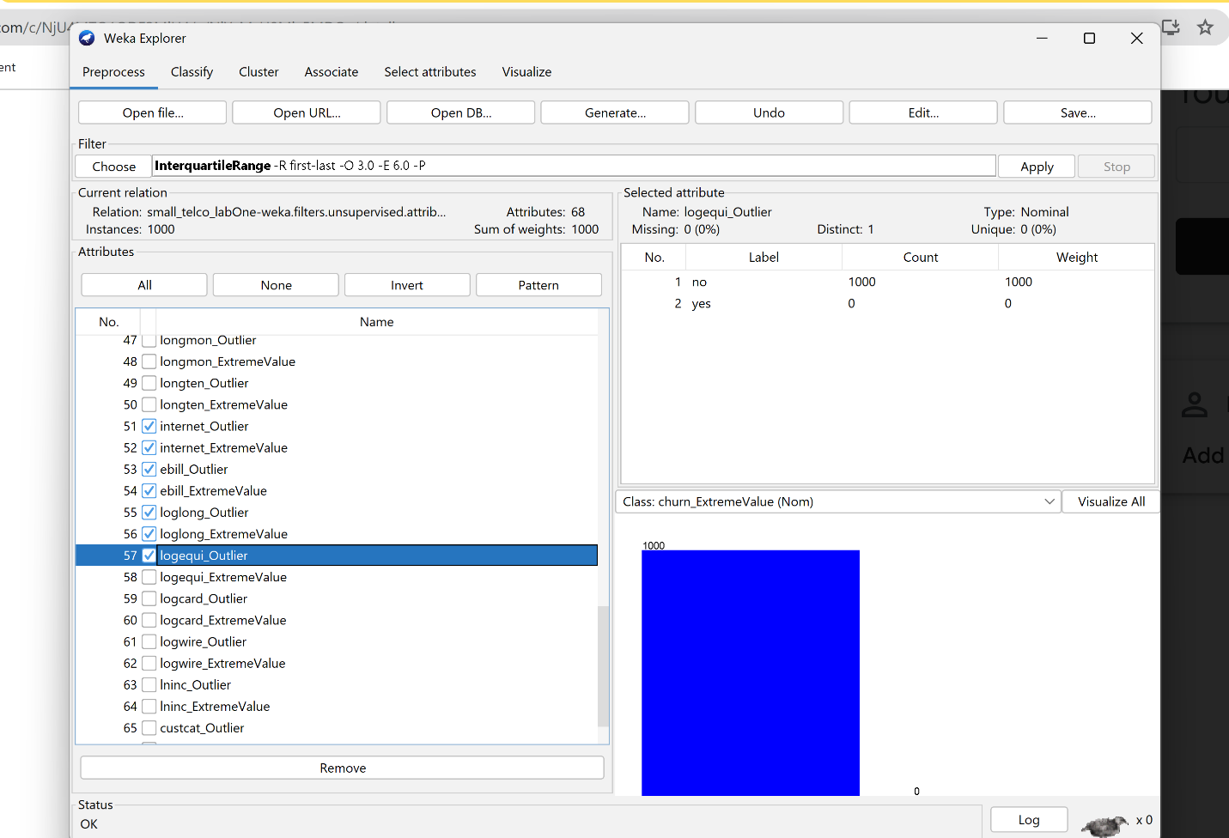

**4: Unsupervised Instance Filter – RemoveWithValues**:

If we fount outlier yes after this all record is removed

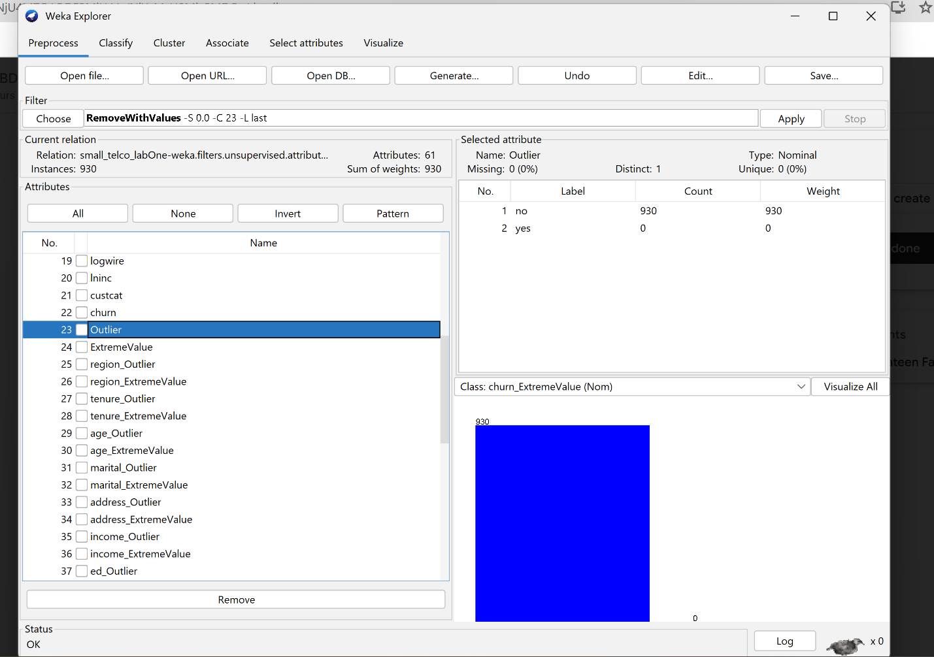

**5:Using filters to perform normalization**

Normalize the data so processing is easy and time complexity is low

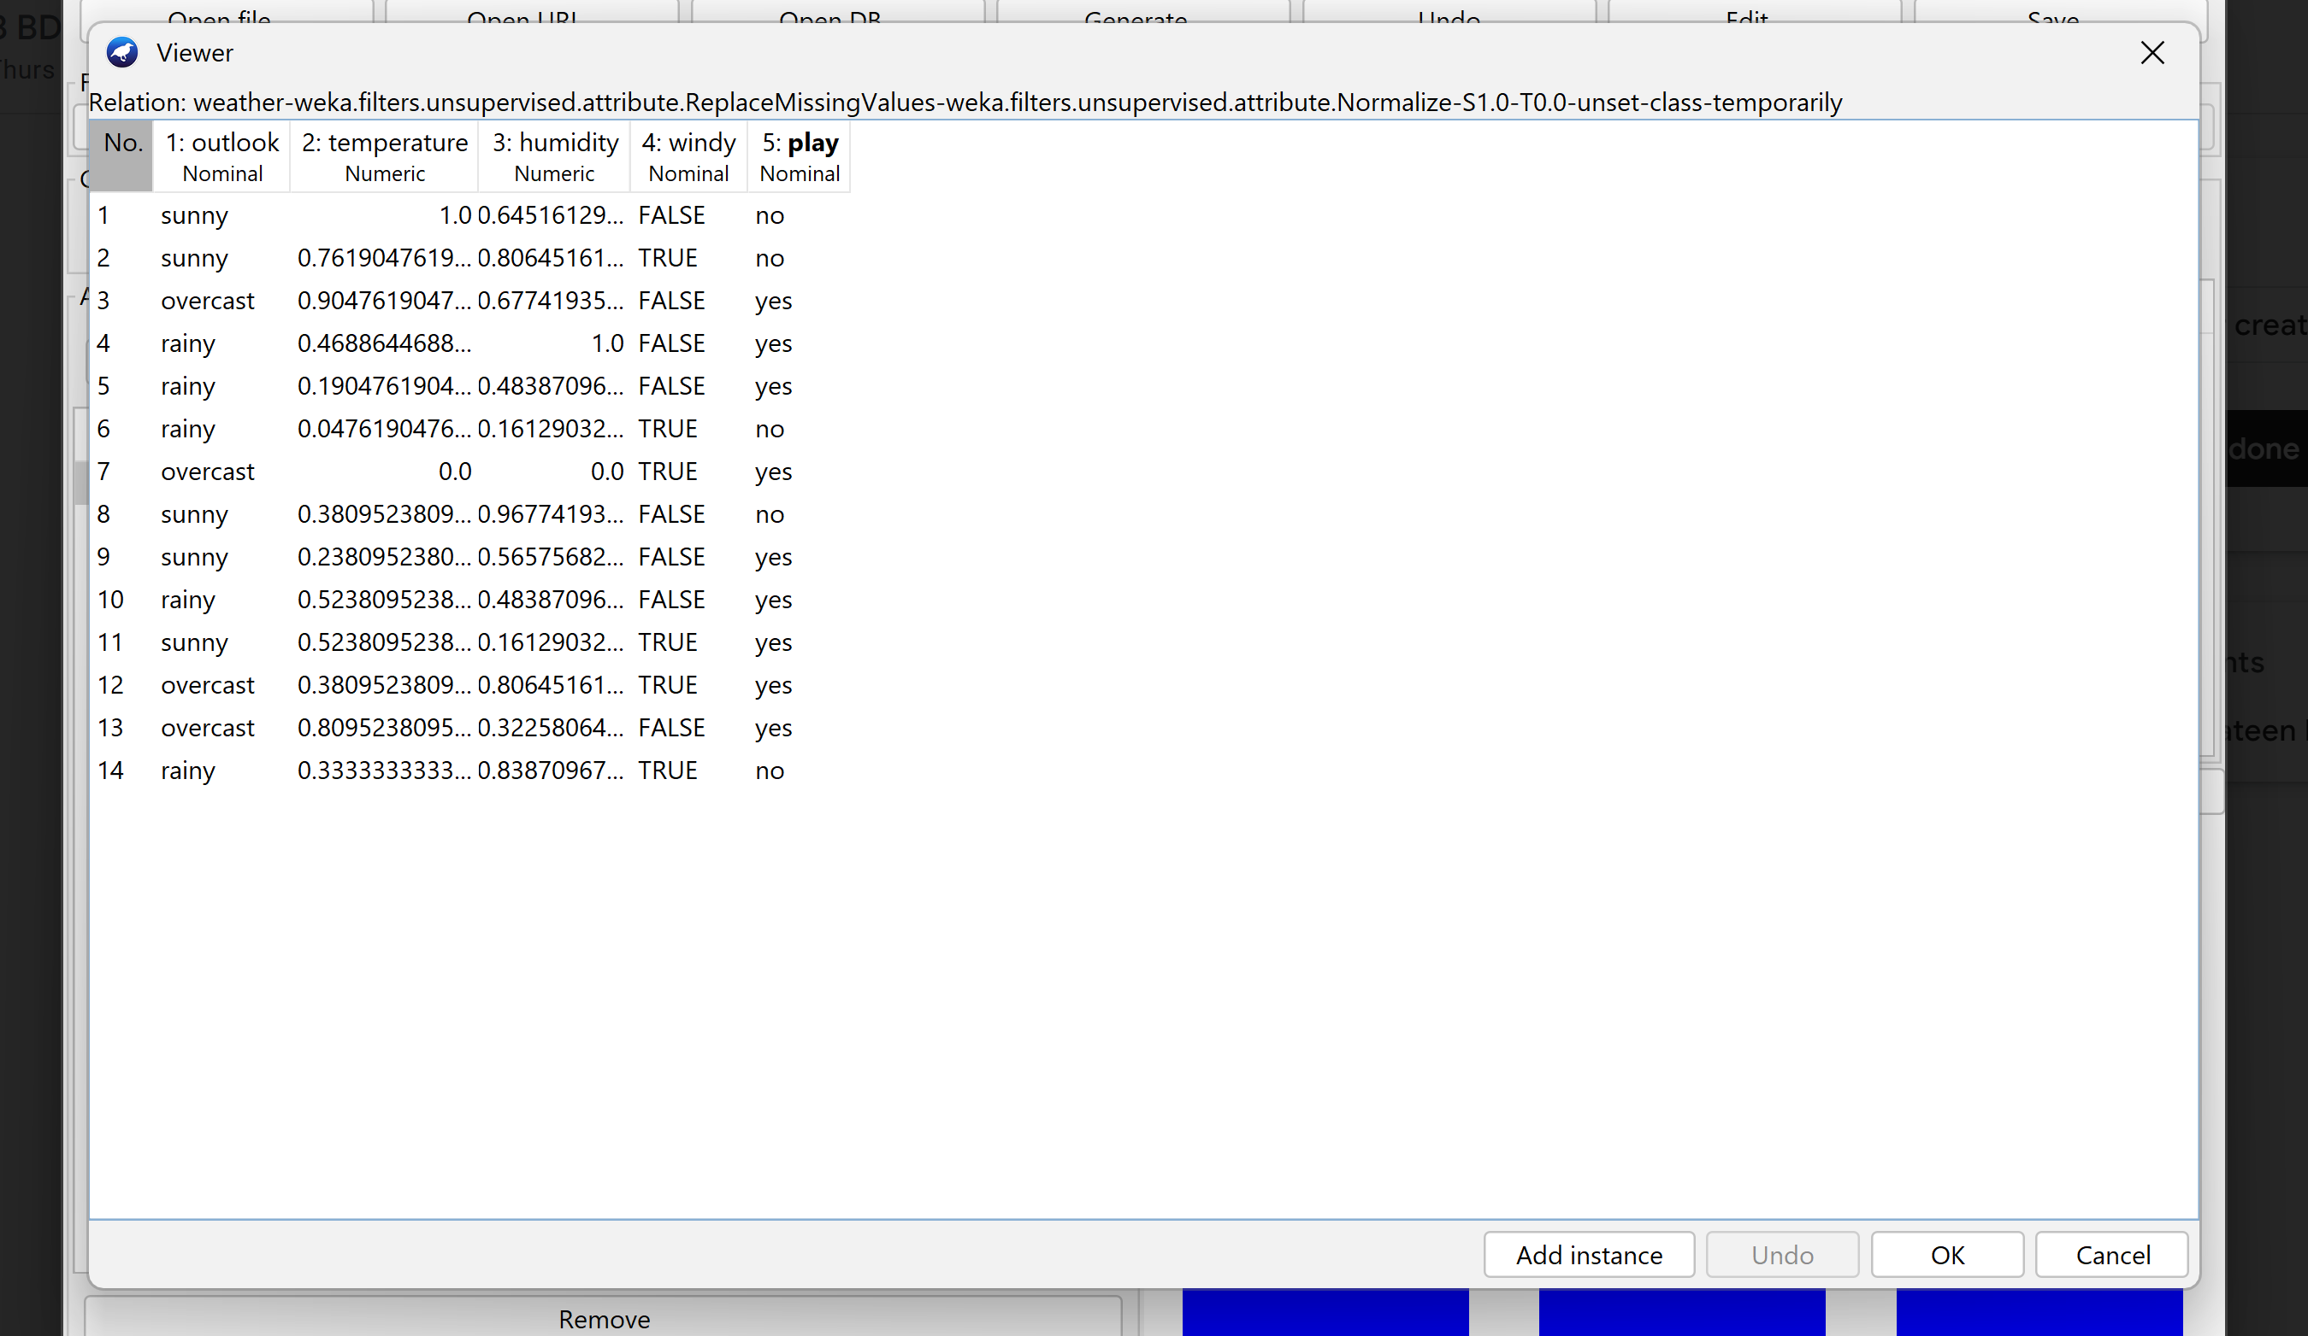

If we choose range from 2 to -1 that suits our work and our requirement

